Why Census Matters for
Southeast Asian American Elders

Every 10 years, the US government is required to count every person living in the United States through a survey called “census.” The next census will start in March 2020, and it will determine how $1.504 trillion in federal funding will be allocated to communities across the country.
DID YOU KNOW?
Almost 14% of all Southeast Asian Americans (SEAAs) in the United States are age 55 or older, with the largest population in the Vietnamese community at 19.4% and the lowest in the Hmong community at just 7%.
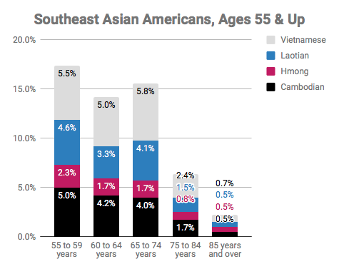

While SEAAs as a community are generally younger compared to the average US population, SEAA elders deal with a unique set of barriers to being counted, such as:
- Limited English proficiency
- Limited technological proficiency
- Low income or live in poverty
- Low educational attainment
- Live in large household

Frequently Asked Question(s)
WHY SHOULD ELDERS CARE ABOUT BEING COUNTED?
The census count determines how many resources will go to programs for the poor and elderly, such as adult education programs, health and educational services for people with disabilities, services to adults with limited English language proficiency, public benefits like food stamps and Medicaid, Medicare, healthcare, hospitals, section 8 affordable housing, senior employment programs, and so much more. When you respond to the census, you help make sure that you and your family get your fair share of $1.504 trillion in federal funding for programs and services critical to your health and well-being.
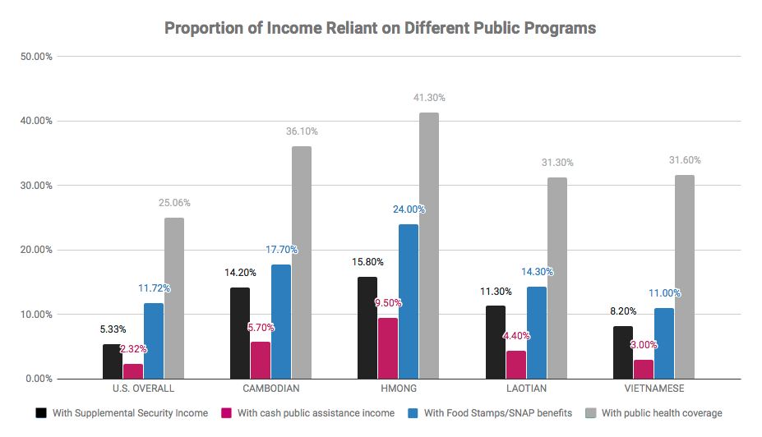
HOW DO I PARTICIPATE IF I DON’T HAVE ACCESS TO A COMPUTER?
You can still participate in the census via the phone or filling out a paper form. While all households may not receive this paper form in the first mailing, all households who have not responded to the questionnaire by the week of April 16-18 can expect a hard copy of the survey in the mail. You can also check with a local community-based organization, community center, or library to see if they can offer assistance or access to a computer.

WHAT SUPPORT IS AVAILABLE TO THOSE WHO DON’T READ, WRITE, OR SPEAK ENGLISH VERY WELL?
The Internet self-response form and census questionnaire assistance phone line are available in 12 non-English languages, including Vietnamese. The Census Bureau is also providing language glossaries, language identification cards, and language guides in 59 non-English languages, including Hmong, Khmer, Laotian, and Vietnamese.

WHAT SUPPORT IS AVAILABLE TO THOSE WHO CANNOT READ?
You can still participate via the telephone.

WHAT SUPPORT IS AVAILABLE FOR THOSE WITH A PHYSICAL DISABILITY AND WOULD HAVE TROUBLE FILLING OUT THE FORM?
You can still participate over the phone or online with accessible technology. You can also ask a family member or friend for assistance in filling out the form.

CAN SOMEONE ELSE FILL OUT THE CENSUS QUESTIONNAIRE FOR ME?
NO. While you can ask for assistance in navigating the form and translating it for you, you cannot have someone else fill out the form on your behalf.

Take Action
There’s power to being counted! Sign up to be a 2020 Census Ambassador and help make sure ALL Southeast Asian Americans are seen and heard. Learn more: 2020census.paperform.co

WHAT CAN YOU DO TO MAKE SURE YOU’RE COUNTED?
- Fill out your census form. Tell your friends and family about the census and explain why it is important to participate.
- Reference the following resource(s) page to find out when the form comes out, how to fill it out, what language support is offered, and more.
- Work for the Census Bureau as an enumerator - the person who goes to peoples’ homes to count them if they do not respond to the census. Find additional information here!

Thank you to our partners Boat People SOS-Houston, Cambodian Families of Santa Ana, Freedom Inc., the Fresno Center, and Iu-Mien Community Services for your generous support with translations. The Word versions of these factsheets are open for download and editing to fit the needs of different communities. For additional questions, contact searac@searac.org.

American Community Survey, 2015 5-year estimates

